**Ideation Phase**

**Define the Problem Statements**

|  |  |
| --- | --- |
| Date | 05 september2023 |
| Team ID | NM2023TMID19094 |
| Project Name | Intelligent garbage classification using deep learning |
| Maximum Marks | 2 Marks |

**Customer Problem Statement Template:**

Create a problem statement to understand your customer's point of view. The proposed deep-learning-based hardware solution SmartBin can segregate the garbage into biodegradable and non-biodegradable using Image classification through a Convolutional Neural Network System Architecture using a Real-time embedded system.

Once an object has been detected the camera will capture its image. It will identify the object as garbage and then further send the signals. The edge detection algorithm is used for the differentiation of the scattered edges and compact and collinear edges of the garbage.

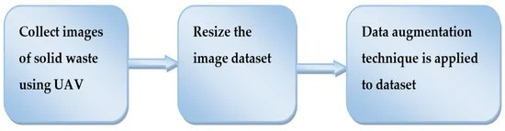Reference: <https://doi.org/10.3390/sym14050960>

**Example:** 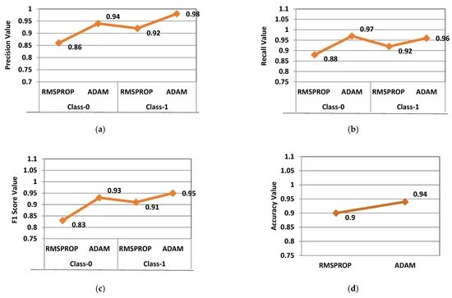

#### The Design of Garbage Sorting Model:

Intelligent decision-making for garbage classification based on big data of items in the scene is the key issue studied in this paper. In order to achieve the intelligent decision of whether items are garbage in the home environment, this paper proposes a garbage detection and classification method based on visual scene understanding.

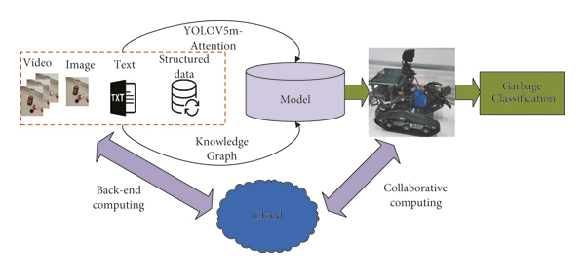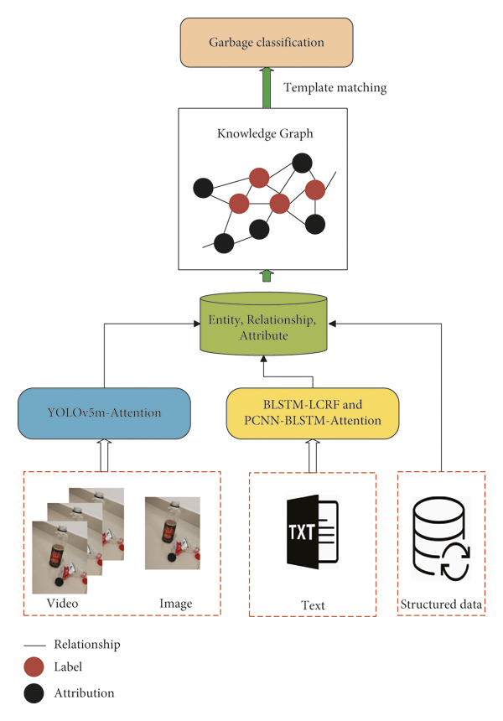 The subsequent chapters of this paper are arranged as follows. Section [2](https://www.hindawi.com/journals/complexity/2021/1055604/#sec2) starts with object detection, including traditional methods and deep learning, and then leads to knowledge graphs and finally mentions edge computing as a demonstration application of the system; the interrelationship between them and how to integrate them into the method proposed in this paper is shown in Section [3](https://www.hindawi.com/journals/complexity/2021/1055604/#sec3); Section [4](https://www.hindawi.com/journals/complexity/2021/1055604/#sec4) discusses the relevant analysis and verification of the experimental results of the model proposed in this paper; Section [5](https://www.hindawi.com/journals/complexity/2021/1055604/#sec5) summarizes the research work of this paper and the prospects for the next research work.